

ANNA UNIVERSITY
NAAN MUDHALVAN – GUIDED PROJECT
SOLUTION ARCHITECTURE

CENTRAL BANK SMART CONTRACT
DATE | 31 OCTOBER 2023
TEAM MEMBERS | - NAVEEN PRASAD R S  - NIKITA R  - PARITHIELAMVAZHUTHI V  - PRASANTH M
PROJECT NAME | CENTRAL BANK SMART CONTRACT
COLLEGE NAME | ALAGAPPA COLLEGE OF TECHNOLOGY, ANNA UNIVERSITY

Solution Architecture:
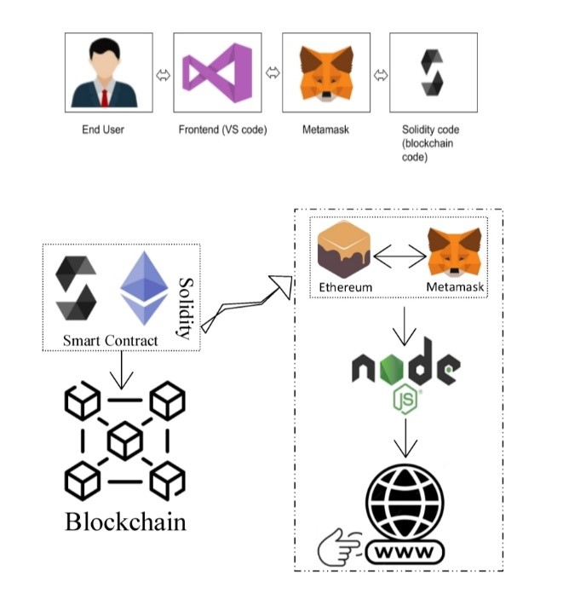
Schematic Diagram of Solution Architecture

Prerequisite:
- download node.js : Node.js
- download vs code: Li4nk
- download metamask : https://metamask.io/
Steps to complete the project
Step 1:-
1. Open the Zip file and download the zip file.
2. Extract all zip files

Step 2 :
1.Open vs code in the left top select open folder. Select extracted file and open .
2. Select the projectname.sol file and copy the code.
3. Open the remix ide platform and create a new file by giving the name of projectname.sol and paste the code which you copied from vs code.
4. Click on solidity compiler and click compile the projectname.sol
5. Deploy the smart contract by clicking on the deploy and run transaction.
6. select injected provider - MetaMask. In environment
7. Click on deploy. Automatically MetaMask will open and give confirmation. You will get a pop up click on ok.
8. In the Deployed contract you can see one address copy the address.
9. Open vs code and search for the connector.js. In contract.js you can paste the address at the bottom of the code. In export const address.
10. Save the code.
Step 3: open file explorer
1. Open the extracted file and click on the folder.
2. Open src, and search for utiles.
3 . You can see the frontend files. Select all the things at the top in the search bar by clicking alt+ A. Search for cmd
4. Open cmd enter commands
npm install
npm bootstrap
npm start
5. It will install all the packages and after completing it will open {LOCALHOST IP ADDRESS} copy the address and open it to chrome so you can see the frontend of your project.

